Choose Your Own Adventure

You will create an adventure that requires your audience to solve circle problems. This is a STORY, so make sure it’s not just a series of problems.

Q# | Questions must be original problems. You can use problems from notes as examples, but you must make up your own values. You should not be directly copying examples from your notes, the book, or another students project.  The image on the misconception page must go with the story as well. For example, in cannot be a thumbs-up or smiley face. It should be a continuation of the story. | ☐ Navigation is correct
Q# |  | ☐ Storyline is cohesive
Q# |  | ☐ Image on each page relates to the story & are copyright free (if your image isn’t part of the story then you must have an image with the story as well as your diagram)
Q# |  | ☐ Quality product (no random or misplaced parts on the form such as Option 1 or “Title”)
Q# |  | ☐ Conclusion page congratulates the winner.
 | Find the angle or arc measure of  inscribed or central angles.  Correct work Misconception | ☐ question diagram is accurate and readable
 |  | ☐ Correct answer is provided
 |  | ☐ Appropriate misconception answer is given
 |  | ☐ Explanation of misconception is correct
 | Find the measure of the segments:  2 Tangents, 2 Secants, or Tangent & Secant  Correct work Misconception | ☐ image for problem is accurate and readable
 |  | ☐ Correct answer is provided
 |  | ☐ Appropriate misconception answer is given
 |  | ☐ Explanation of misconception is correct
 | Find the segment length of two intersecting chords  Correct work Misconception | ☐ image for problem is accurate and readable
 |  | ☐ Correct answer is provided
 |  | ☐ Appropriate misconception answer is given
 |  | ☐ Explanation of misconception is correct

 | Find the Arc length or angle measure  of intersecting chords secants tangents  Correct work Misconception | ☐ image for problem is accurate and readable
 |  | ☐ Correct answer is provided
 |  | ☐ Appropriate misconception answer is given
 |  | ☐ Explanation of misconception is correct
 | Choice of own problem different from the four above.  Type:  Correct work Misconception | ☐ image for problem is accurate and readable
 |  | ☐ Correct answer is provided
 |  | ☐ Appropriate misconception answer is given
 |  | ☐ Explanation of misconception is correct
Peer-evaluated by at least 1 person checking for errors and providing specific feedback for improvement. |  | Evaluator:
Summary of corrections made (2 points):

+2 BONUS points if your images are part of the story. Example:
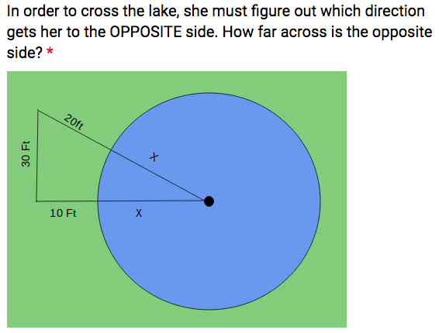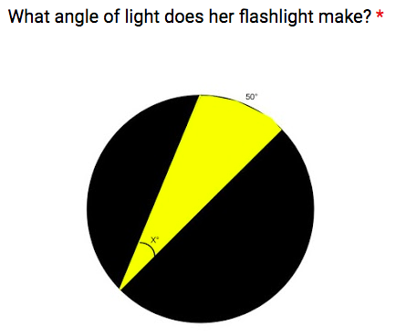
/28

